Project Design Phase-I - Solution Fit Template

**Project Title:** Natural Disaster Intensity Analysis and **Team ID:PNT2022TMID28517**

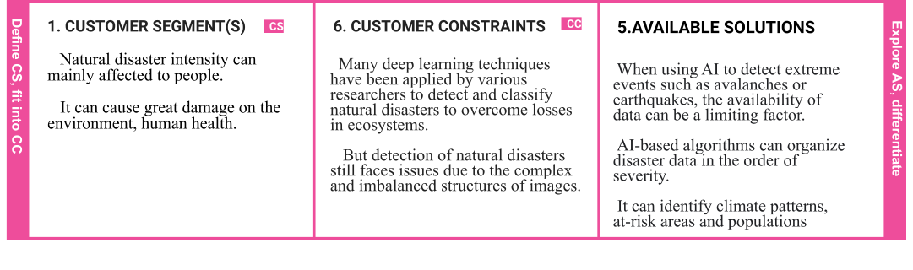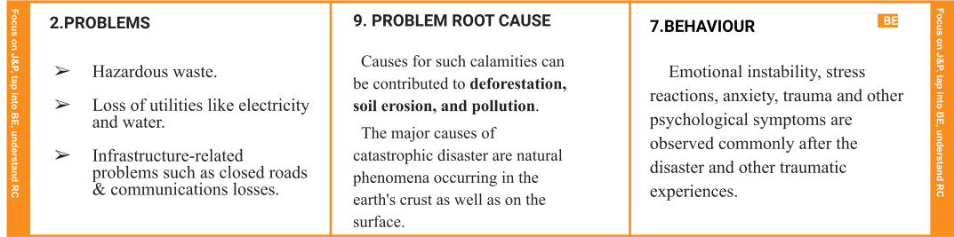

Classification using Artificial Intelligence

|  |  |  |  |  |
| --- | --- | --- | --- | --- |
|  | **3. TRIGGERS**  Disaster can be caused by natural, man-made and technological  Hazardous, as well as various factors that influence the exposure and vulnerability of a community. | 1. **YOUR SOLUTION**    * AI-based algorithms can organise disaster data in the order of severity.  * It can identify climate patterns, at-risk areas and populations, and send early warnings for potentially disastrous weather events. * AI can be used to foretell the economic and human impact of natural disasters. | **8.CHANNELS of BEHAVIOUR CH**  **ONLINE**  Researchers are applying artificial intelligence to accurately predict natural disasters.  Multispectral Images using Multi-layered Deep Convolutional Neural Network.  **OFFLINE**  Drones and robots have been used to locate survivors and transmit information to emergency teams.  The SERVAL project was developed in response to the Haiti earthquakes. |  |
| **4. EMOTIONS: BEFORE / AFTER EM**  Emotional instability, stress reactions, anxiety, trauma and other psychological symptoms are observed commonly after the disaster and other traumatic experiences.  These psychological effects have a massive impact on the concerned individual & also on communities. |